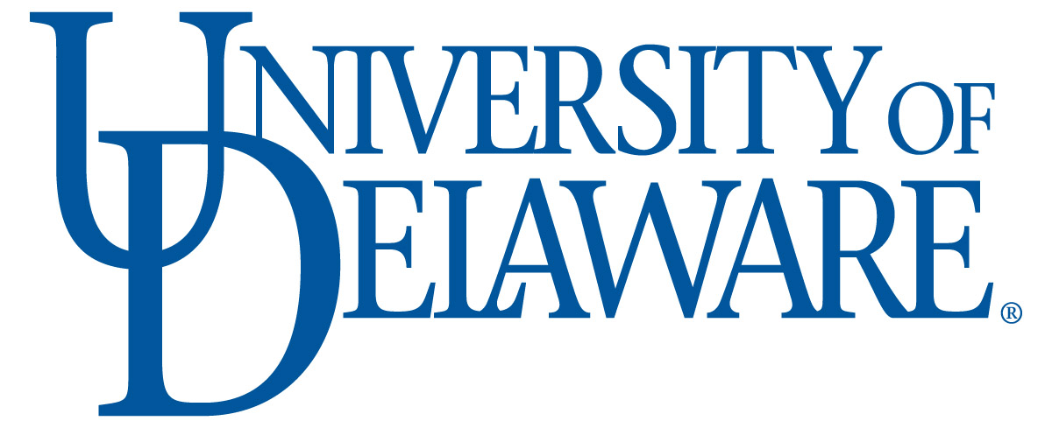 | Biotechnology PSM Internship  FINAL Evaluation Form for Employers | 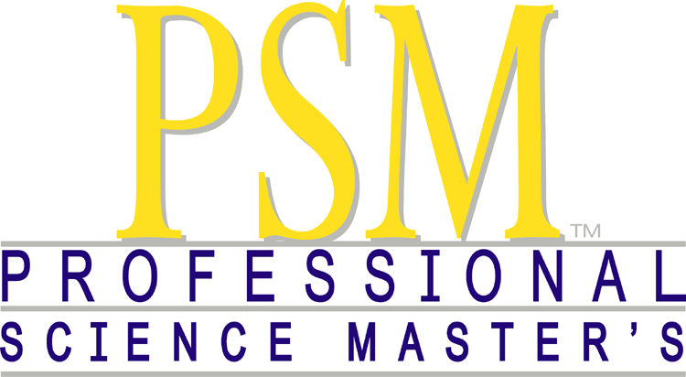

Student Name: |  |  | Date:
Company/Organization:
Supervisor: |  |  | Phone #:
How long was the internship: | Was the internship full- or part-time?
Please rate the intern in the following areas, using a scale of 1 – 5 where 1 is poor and 5 is excellent. Please feel free to write additional comments in the feedback section below.
1. Overall quality of assignments completed:
2. Ability to communicate in writing:
3. Ability to communicate verbally:
4. Attitude and enthusiasm for assignments:
5. Aptitude for learning:
6. Judgment/decision making:
7. Ability to work with others:
8. Dependability:
9. Professional demeanor:
10. Attendance/punctuality:
11. Overall performance:
Additional comments & feedback:

Were you satisfied with the intern’s performance? Please describe.

How did the intern’s performance improve over the course of the internships?

Please use the space below to provide feedback and suggestions to the PSM program on the structure of and the intern’s preparation for the internship:

Did any issues arise over the course of the internship?
If yes, where they resolved to your satisfaction?

Would you consider this intern for full-time, permanent employment?
Please comment:

Would you consider another intern from the PSM program?
Please comment:

Please return this form to: Melinda Duncan, Program Director
Department of Biological Sciences
Wolf Hall
University of Delaware
Newark, DE 19716
OR email duncanm@udel.edu

